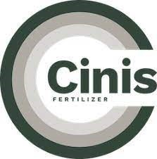
Cinis Fertilizer AB (publ)
Super Senior Secured Fixed Rate Callable Green Bonds 2025/2027
SE0025010549

Start of Interest Period | End of Interest Period | Days | Deferred Interest
2025-06-18 | 2025-08-26 | 68 | 3,966,666.67
2025-08-26 | 2025-11-26 | 90 | 5,349,166.67
2025-11-26 | 2026-02-26 | 90 | 5,482,895.83
2026-02-26 | 2026-05-26 | 90 | 5,619,968.23
 |  | Total: | 20,418,697.40
This document is published for the purpose of illustrating the Deferred Interest accruing in respect the Bonds issued by Cinis Fertilizer AB (publ) under ISIN SE0025010549. The calculations are prepared on the basis that the Bonds have not, and will not prior to May 26, 2026, be redeemed. Terms not defined herein shall have the meaning given to them in the term and conditions for the Bonds dated May 26, 2025.

